Digital-Nurture-4.0-JavaFSE-main

Hands-on in this document

Name:  Thilak Ragav M

Superset ID : 6409405

Week Task : Week - 6

## **Objectives**

* Explain React components
* Identify the differences between components and JavaScript functions
* Identify the types of components
* Explain class component
* Explain function component
* Define component constructor
* Define render() function

In this hands-on lab, you will learn how to:

* Create a function component
* Apply style to components
* Render a component

## **Prerequisites**

The following is required to complete this hands-on lab:

* Node.js
* NPM
* Visual Studio Code

## **Notes**

Estimated time to complete this lab: **30 minutes.**

Create a react app for Student Management Portal named scorecalculatorapp and create a function component named “CalculateScore” which will accept Name, School, Total and goal in order to calculate the average score of a student and display the same.

1. Create a React project named “scorecalculatorapp” type the following command in terminal of Visual studio:



1. Create a new folder under Src folder with the name “Components”. Add a new file named “CalculateScore.js”
2. Type the following code in CalculateScore.js

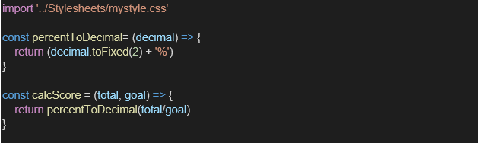

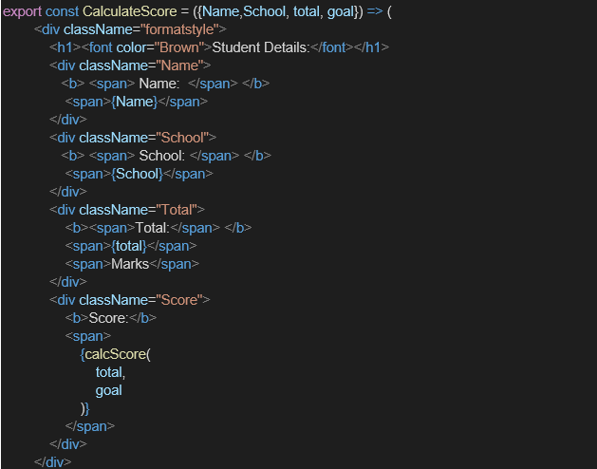

1. Create a Folder named Stylesheets and add a file named “mystyle.css” in order to add some styles to the components:

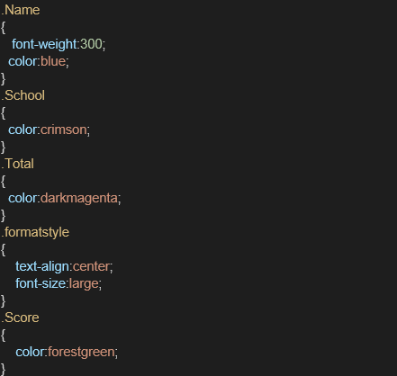

1. Edit the App.js to invoke the CalculateScore functional component as follows:

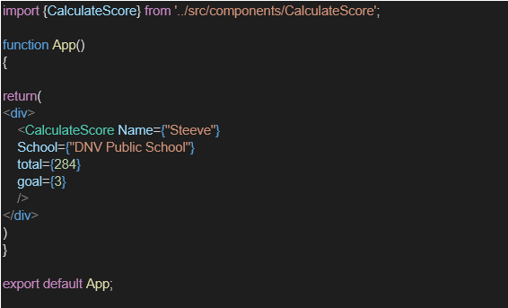

1. In command Prompt, navigate into scorecalculatorapp and execute the code by typing the following command:



1. Open browser and type “localhost:3000” in the address bar:

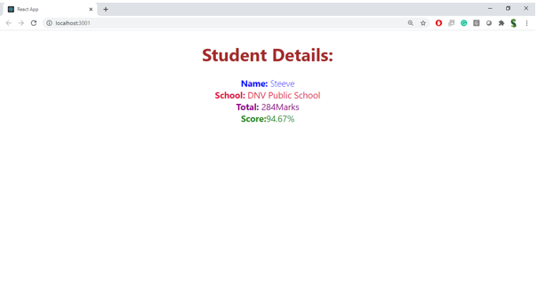

Index.js

import React from 'react';import ReactDOM from 'react-dom/client';import './index.css';import App from './App';import reportWebVitals from './reportWebVitals';const root = ReactDOM.createRoot(document.getElementById('root'));root.render( <React.StrictMode> <App /> </React.StrictMode>);// If you want to start measuring performance in your app, pass a function// to log results (for example: reportWebVitals(console.log))// or send to an analytics endpoint. Learn more: https://bit.ly/CRA-vitalsreportWebVitals();

App.js

import CalculateScore from './Components/CalculateScore';function App() { return ( <div> <CalculateScore Name="Thilak ragav" School="KMMHSS School" total={597} goal={5} /> </div> );}export default App;

Package.json:

{ "name": "scorecalculatorapp", "version": "0.1.0", "private": true, "dependencies": { "@testing-library/dom": "^10.4.0", "@testing-library/jest-dom": "^6.6.3", "@testing-library/react": "^16.3.0", "@testing-library/user-event": "^13.5.0", "react": "^19.1.0", "react-dom": "^19.1.0", "react-scripts": "5.0.1", "web-vitals": "^2.1.4" }, "scripts": { "start": "react-scripts start", "build": "react-scripts build", "test": "react-scripts test", "eject": "react-scripts eject" }, "eslintConfig": { "extends": [ "react-app", "react-app/jest" ] }, "browserslist": { "production": [ ">0.2%", "not dead", "not op_mini all" ], "development": [ "last 1 chrome version", "last 1 firefox version", "last 1 safari version" ] }}

Output:

